API Documentation

API Gateway Service (Port: 8765) - Public Endpoints
Method | Endpoint | Description
POST | /api/v1.0/auth/signin | User login/authentication
POST | /api/v1.0/auth/signup | User registration
POST | /api/v1.0/auth/signout | User logout
GET | /health | Health check

Flight Service - Public Endpoints
Method | Endpoint | Description
GET | /api/v1.0/flight/admin/flights/health | Health check
POST | /api/v1.0/flight/admin/search | Search flights (origin, destination, date)
GET | /api/v1.0/flight/admin/internal/schedules/{id} | Get schedule by ID (internal service-to-service)
POST | /api/v1.0/flight/admin/internal/schedules/{id}/lock-seats | Lock seats (internal service-to-service)
POST | /api/v1.0/flight/admin/internal/schedules/{id}/release-seats | Release seats (internal service-to-service)

Flight Service - Admin Protected endpoints
Method | Endpoint | Description
POST | /api/v1.0/flight/admin/flights | Create a new flight
GET | /api/v1.0/flight/admin/flights | Get all flights
GET | /api/v1.0/flight/admin/flights/{flightNumber} | Get flight by flight number
DELETE | /api/v1.0/flight/admin/flights/{id} | Delete a flight
POST | /api/v1.0/flight/admin/inventory | Add flight schedule/inventory

Booking Service - User Protected Endpoints (ROLE_USER or ROLE_ADMIN)
Method | Endpoint | Description
POST | /api/v1.0/flight/booking/{scheduleId} | Create a new booking
GET | /api/v1.0/flight/booking/{pnr} | Get booking by PNR
GET | /api/v1.0/flight/bookings/email/{email} | Get all bookings by email
DELETE | /api/v1.0/flight/booking/cancel/{pnr} | Cancel a booking
GET | /api/v1.0/flight/ticket/{pnr} | Get ticket by PNR

Docker screenshots

docker compose up
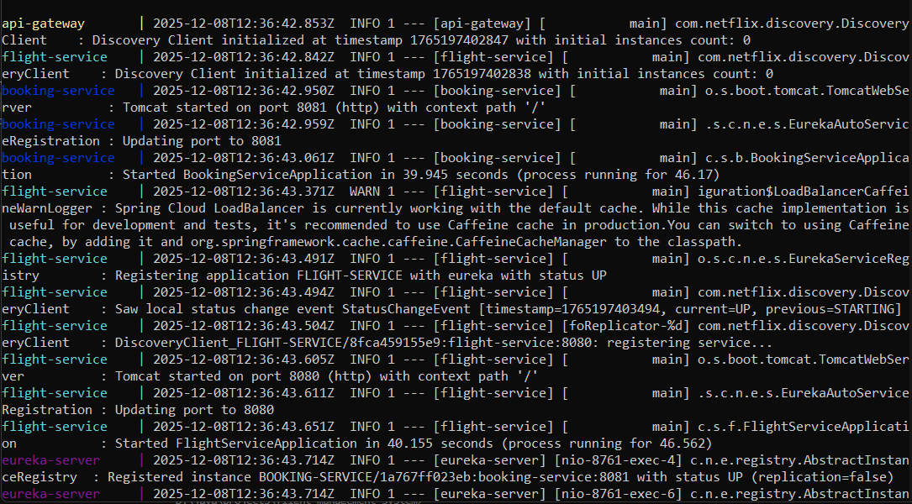

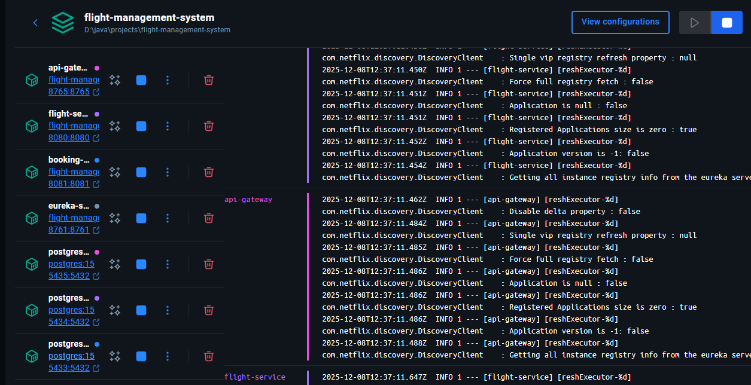

docker logs -f api-gateway
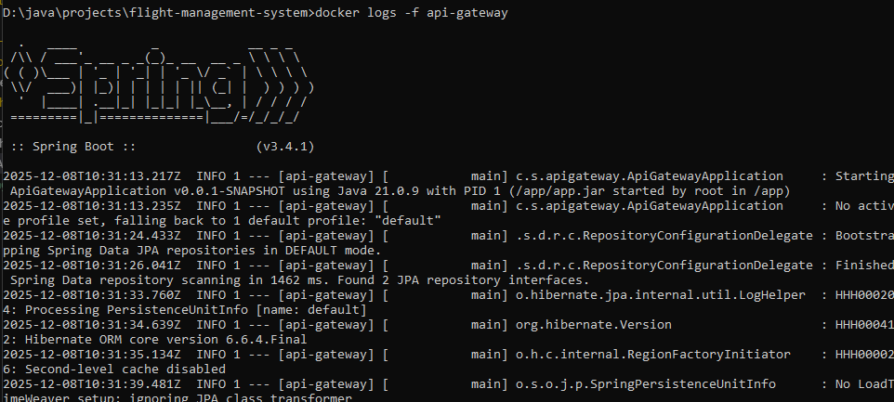

docker logs -f flight-service
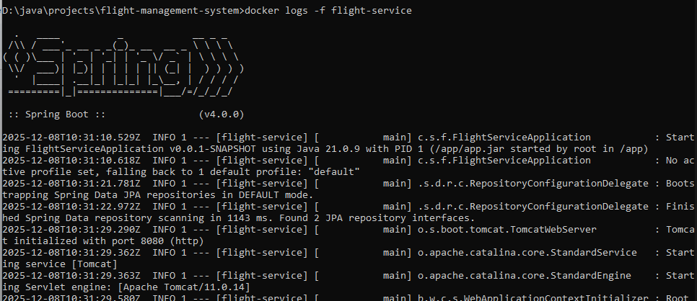

docker logs -f booking-service
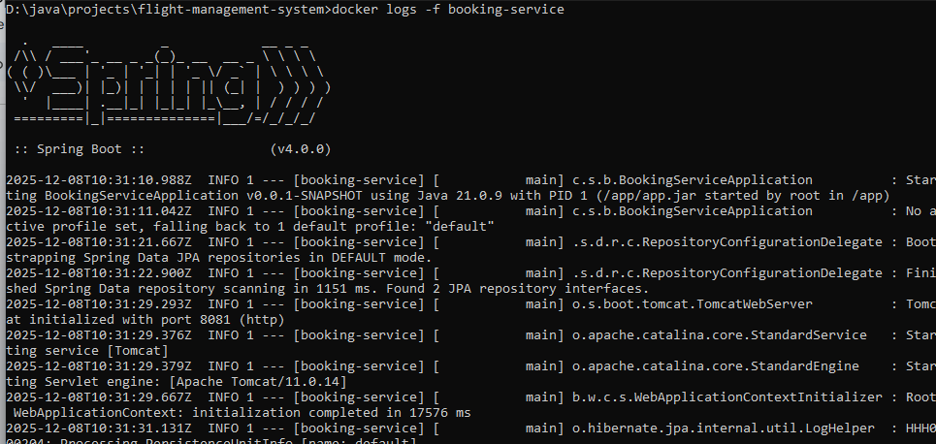

Postman Screenshots
User Register - public route
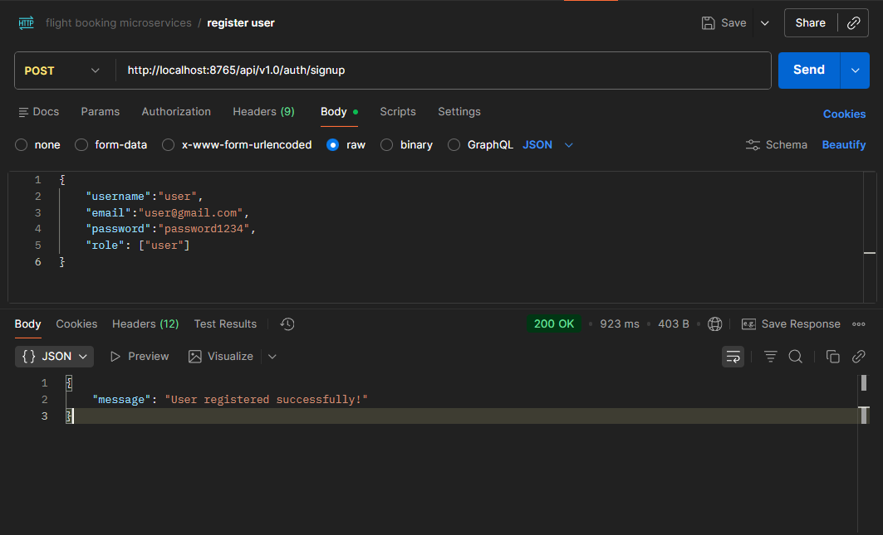

User Login - public route

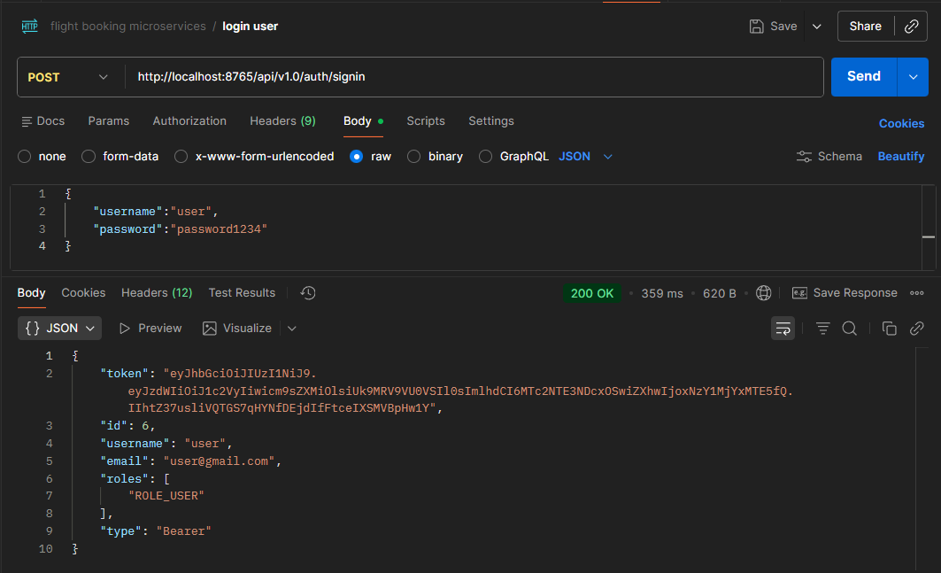

Admin Signup - public route
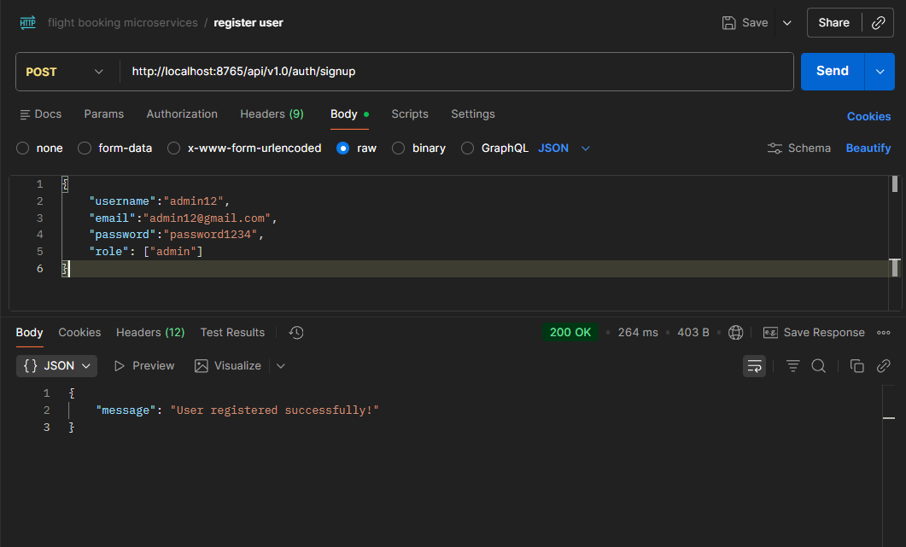
Admin Login - public route
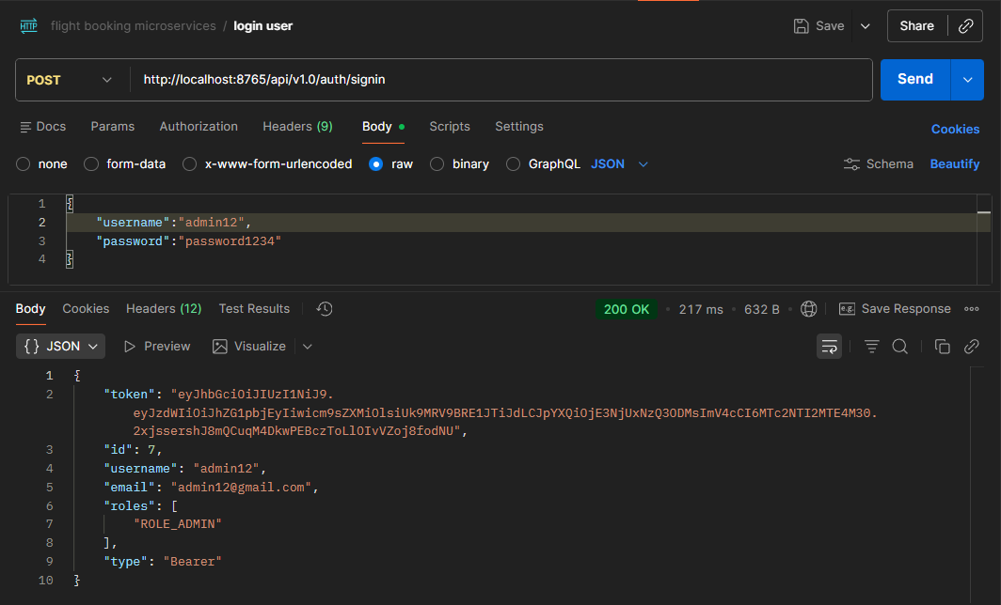
Admin only protected routes
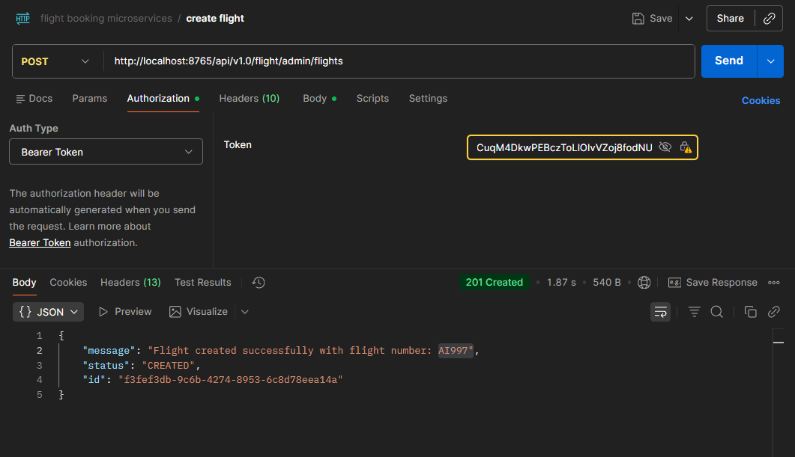

Negative test - without Bearer token - 401 unauthorized
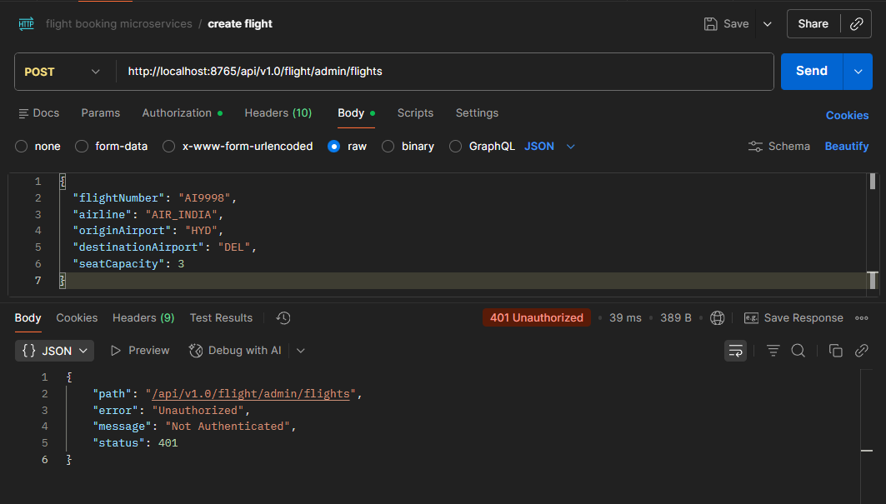

Get all flights - with admin bearer token

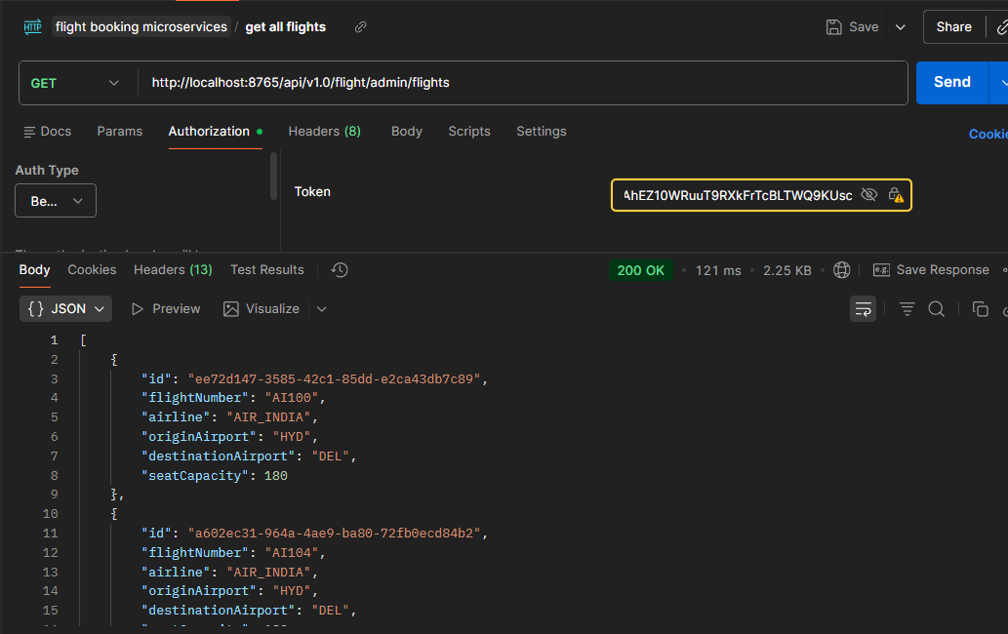

Negative test
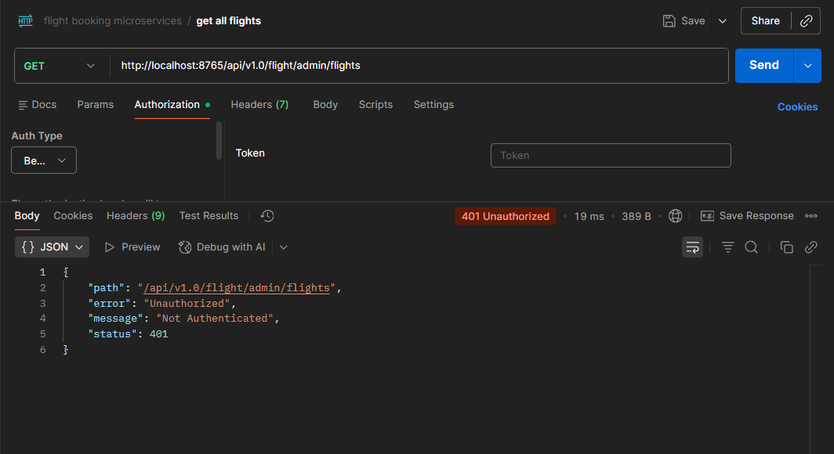
Get Flight By Id
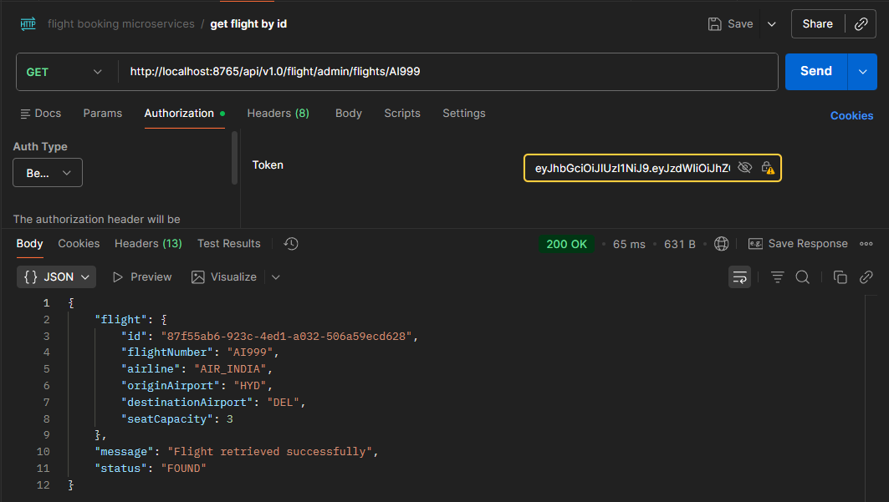

Delete Flight
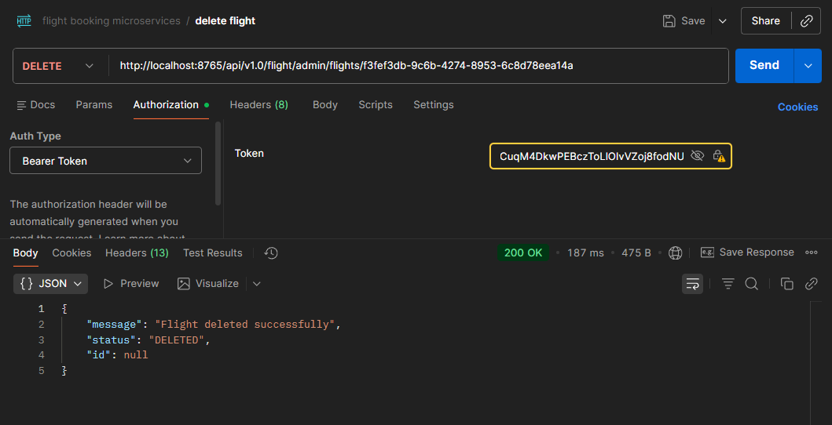

Create Flight Schedule
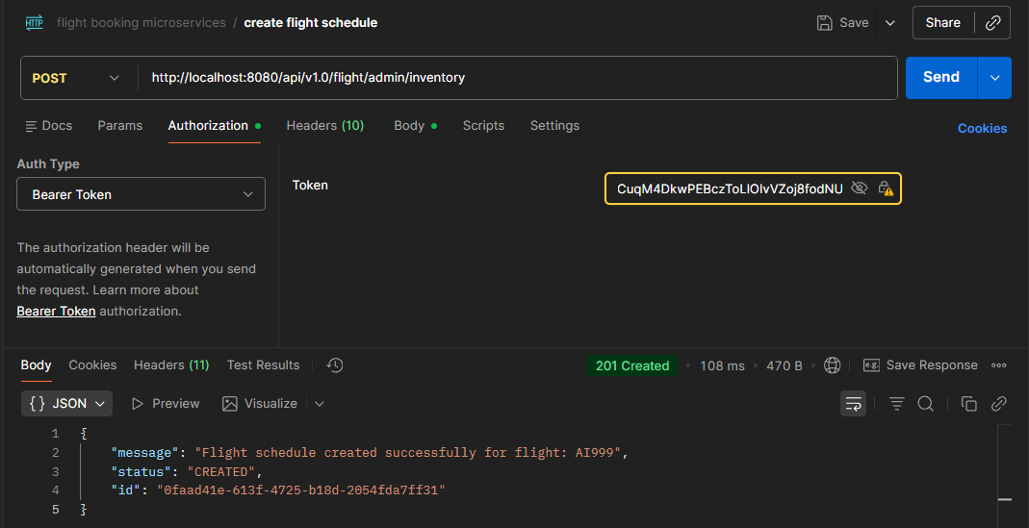

Search Flight Schedule - public route (Anyone can access this end point)
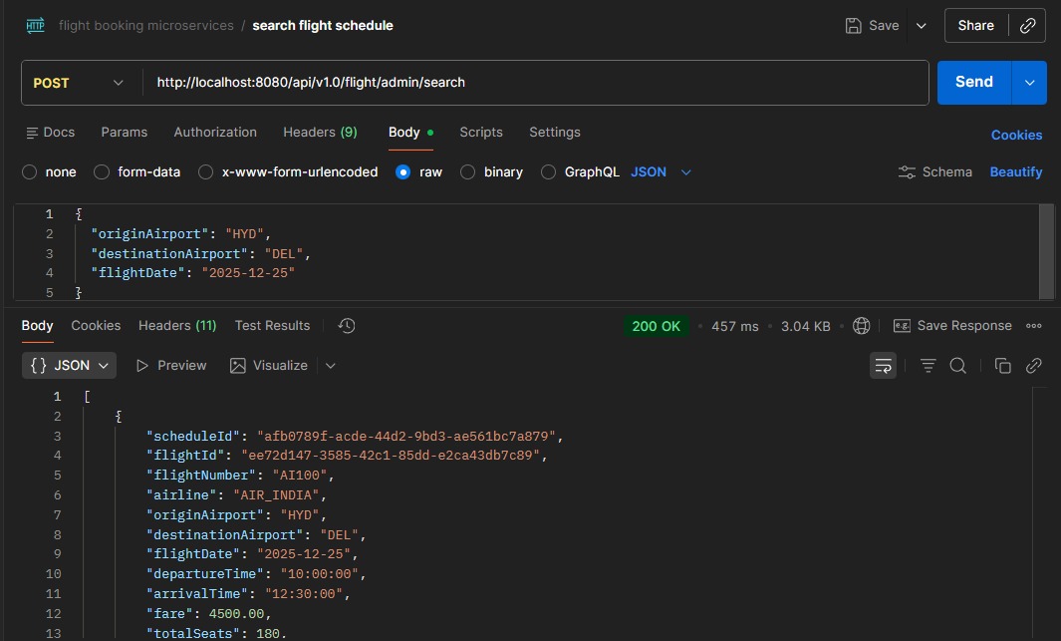

Create Booking - Admin & User protected
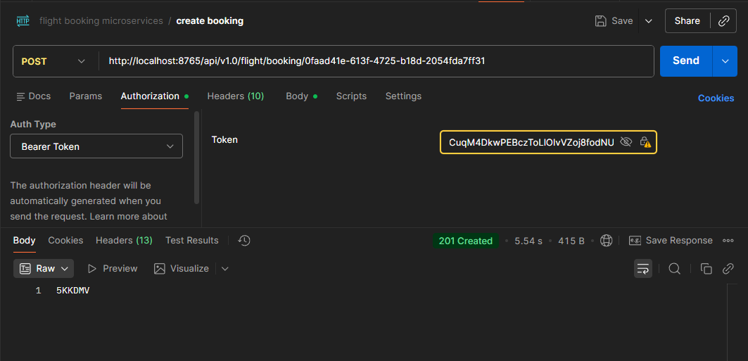

Get Booking by PNR - Admin & User protected
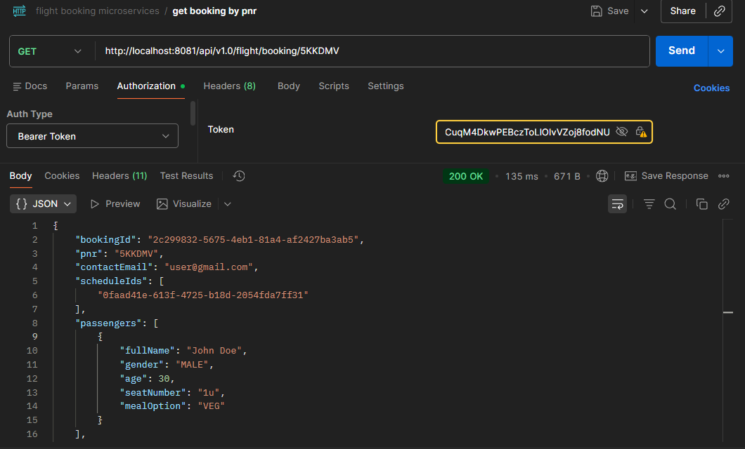

Delete Booking - Admin & User protected
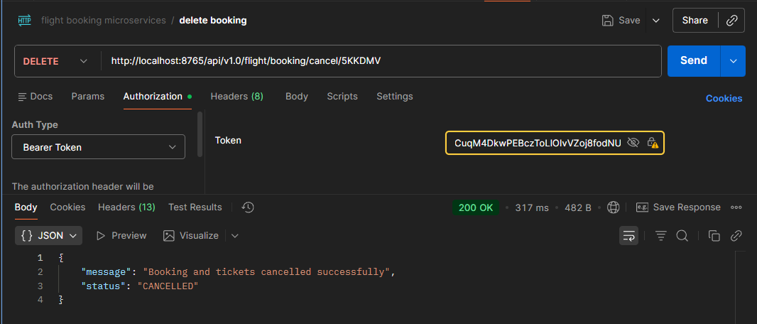

Get Ticket from PNR - Admin & User protected
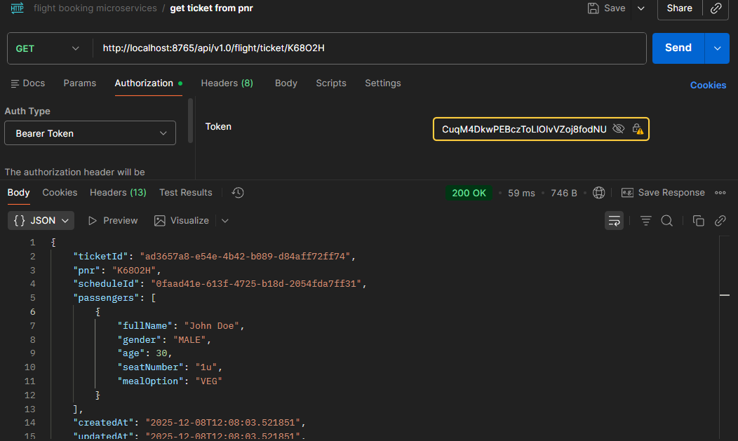

Get Booking from Email - Admin & User protected
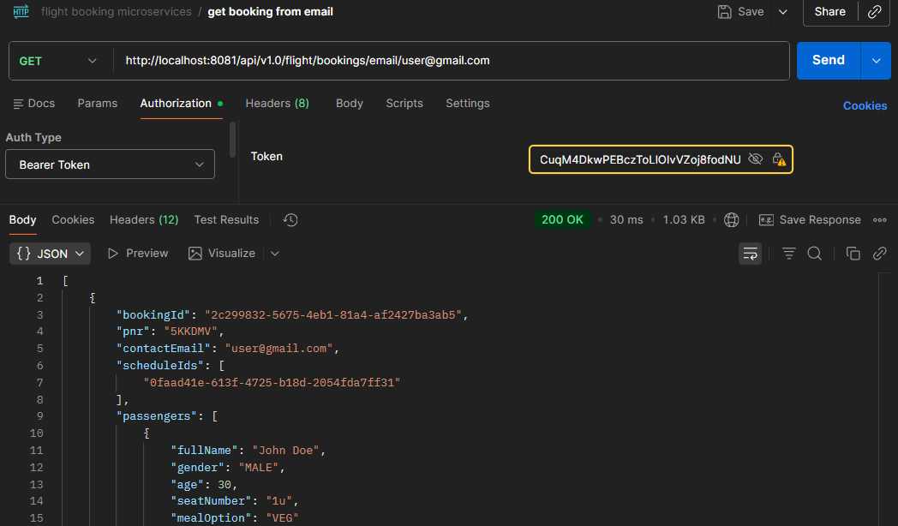

Jacoco report - api-gateway
